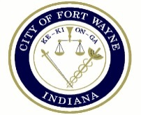

Fifth Tuesday – August 29, 2017

Special Session: Community Opioid Discussion

Since there is no Common Council meeting held on the Fifth Tuesday of a month, there will be a special public discussion of the opioid crisis in our community. This discussion, hosted by Councilman Geoff Paddock, will include speakers from the Fort Wayne Police Department, Allen County Health Department and area treatment centers.

This discussion will begin at 5:30 PM in Room 030 – Council Discussion Room on the Garden Level of Citizen’s Square (200 E Berry St, Fort Wayne IN 46802). This is open to the public.